Bash Scripting assignment 02
Git-hub Repository: https://github.com/majeedkhan91/bash-linux-automation

If-then Scripts:
Check the variable
#!/bin/bash

count=100
if [ $count -eq 100 ]
then
echo Count is 100
else
echo Count is not 100
fi
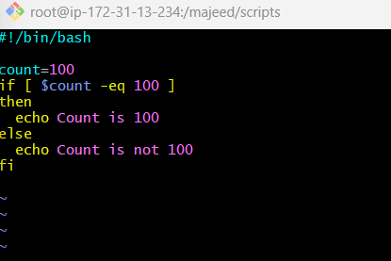
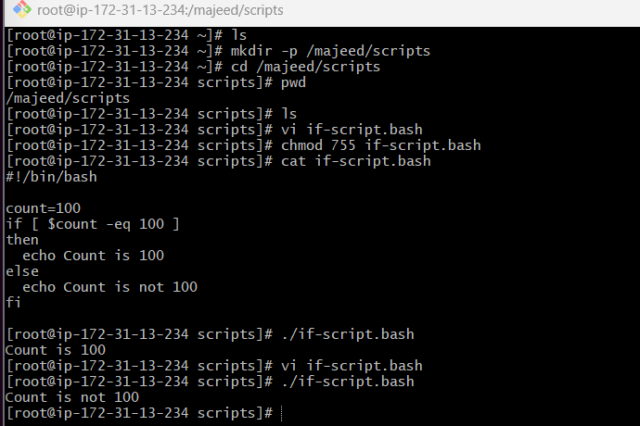
_________________________________________________________________________________
Check if a file error.txt exist
#!/bin/bash
clear
if [ -e /home/iafzal/error.txt ]
then
echo "File exist"
else
echo "File does not exist"
fi
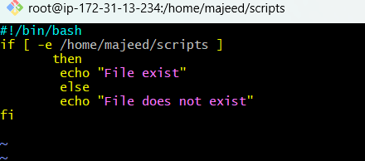
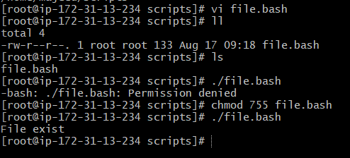
case Scripts:
#!/bin/bash
echo
echo Please chose one of the options below
echo
echo 'a = Display Date and Time'
echo 'b = List file and directories'
echo 'c = List users logged in'
echo 'd = Check System uptime'
echo
read choices
case $choices in

a) date;;
b) ls;;
c) who;;
d) uptime;;
*) echo Invalid choice - Bye.

Esac
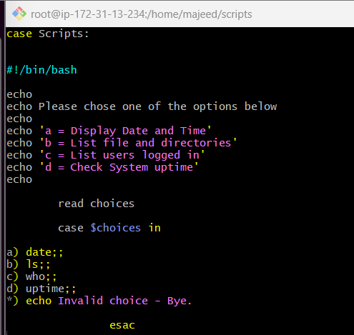
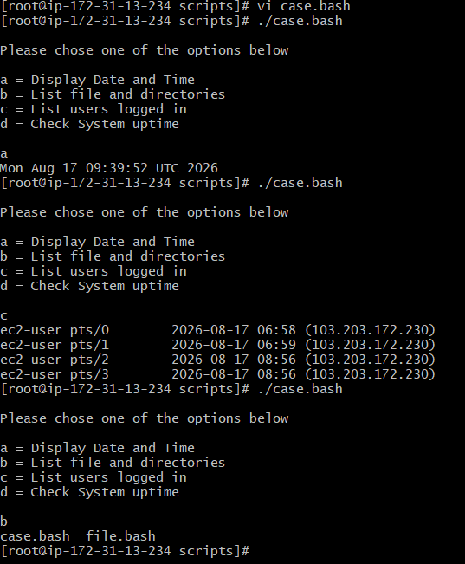
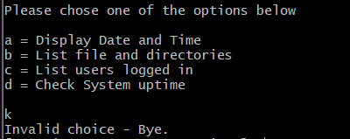

for loop Scripts:
Simple for loop output
#!/bin/bash
for i in 1 2 3 4 5
do
echo "Welcome $i times"
done
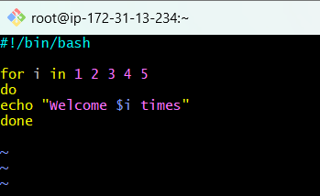
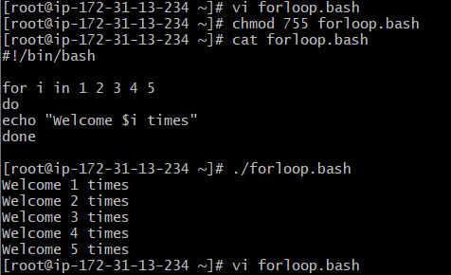
#!/bin/bash
for i in {1..100}
do
echo "Welcome $i times"
done
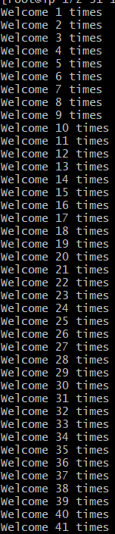
Simple for loop output
#!/bin/bash
for i in eat run jump play
do
echo See Imran $i
done
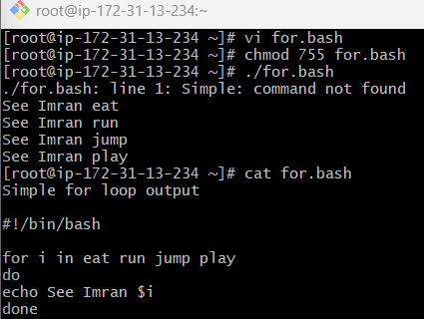
Script to run for a number of seconds
#!/bin/bash
count=0
num=10
while [ $count -lt 10 ]
do
echo
echo $num seconds left to stop this process $1
echo
sleep 1
num=`expr $num - 1`
count=`expr $count + 1`
done
echo
echo $1 process is stopped!!!
Echo
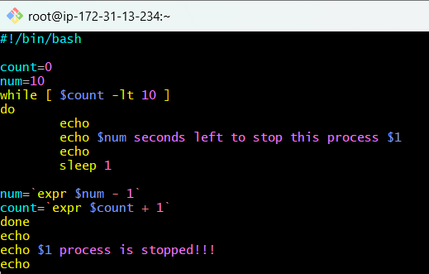
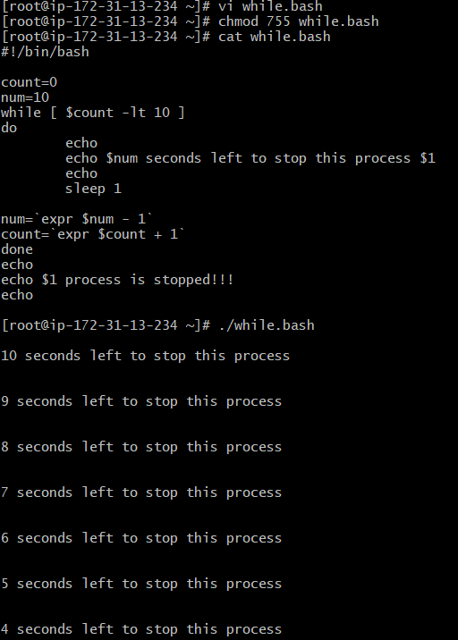

Return exist status if file exist
#!/bin/bash
ls -l /home/iafzal/check
if [ $? -eq 0 ]
then
echo File exist
else
echo File does not exist
fi
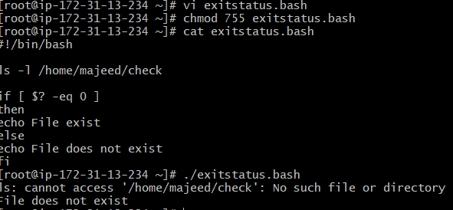
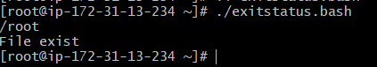

How to schedule a cron job
list crontab - crontab -l edit crontab - crontab –e remove crontab - crontab -r backup crontab - crontab –l
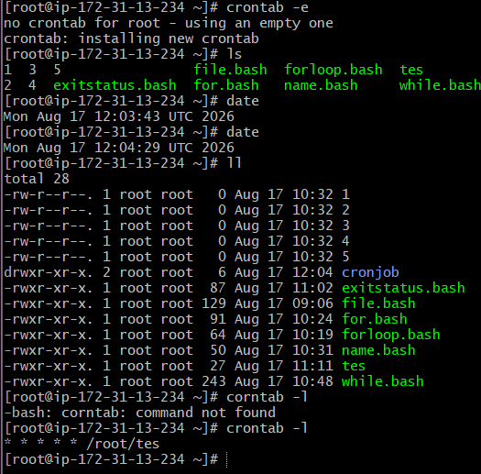
Bash Script Tasks
1: Create a bash script to check if a directory is available or not.
#!/bin/bash
if [ -d /home/majeed/scripts ]
then
echo "Directory exists"
else
echo "Directory does not exist"
fi
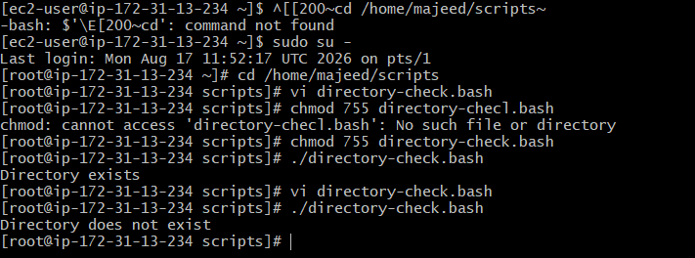
2: Create a bash script to create multiple files.
#!/bin/bash
touch file1.txt
touch file2.txt
touch file3.txt
echo "Files created successfully"
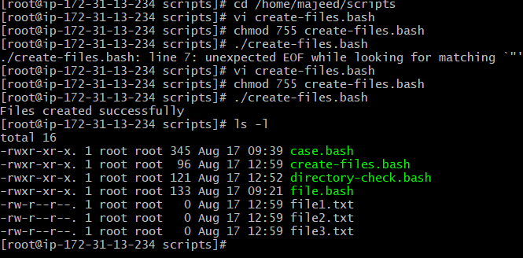
3: Create a bash script to take a backup of a directory.
#!/bin/bash
tar -czf /home/majeed/scripts-backup.tar.gz /home/majeed/scripts
echo "Backup created successfully"
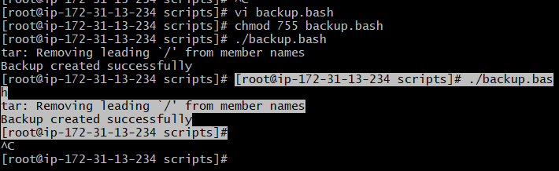
4: Create a bash script to install Nginx on an EC2 server :
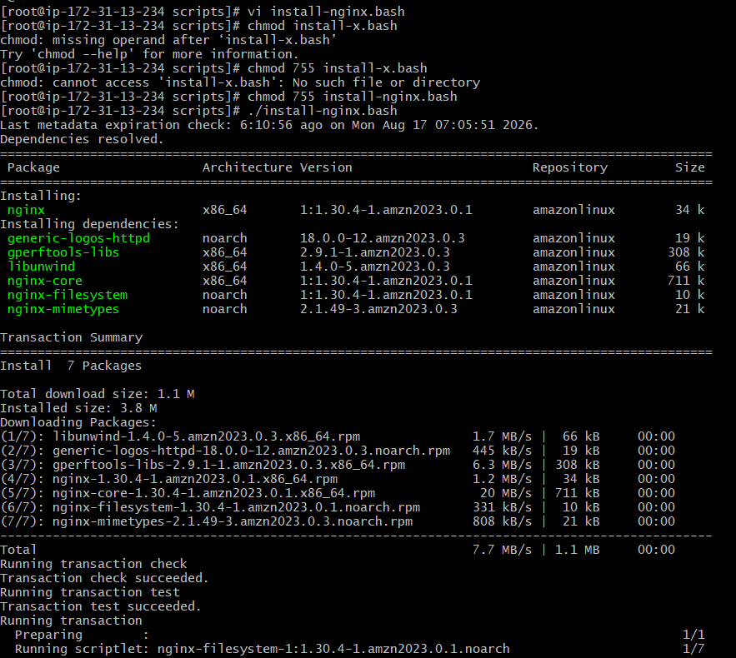
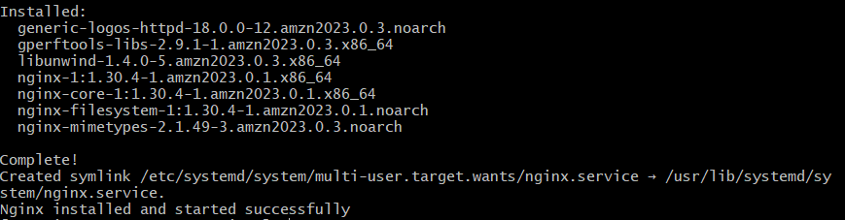

5: Create a bash script to install Apache Tomcat on an EC2 server:
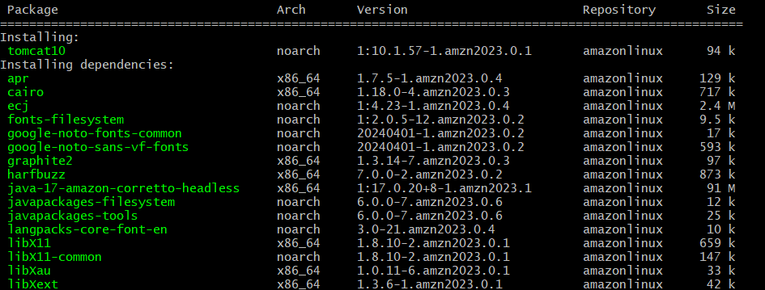
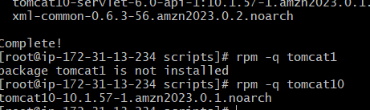
6: Create a bash script to check if the Nginx service is running, if not running then script should start the service.
#!/bin/bash
if systemctl is-active --quiet nginx
then
echo "Nginx is running"
else
echo "Nginx is not running"
systemctl start nginx
echo "Nginx service started"
fi
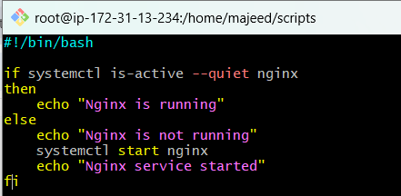
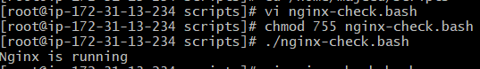
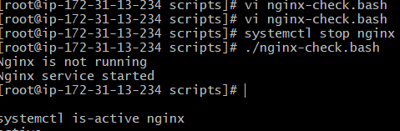

7: Create a bash script for a calculator.
cd /home/majeed/scripts
vi calculator.bas
#!/bin/bash
echo "Enter first number:"
read num1
echo "Enter second number:"
read num2

echo "Enter operation (+, -, *, /):"
read operation
case $operation in
+)
echo "Result: $((num1 + num2))"
;;
-)
echo "Result: $((num1 - num2))"
;;
\*)
echo "Result: $((num1 * num2))"
;;
/)
echo "Result: $((num1 / num2))"
;;
*)
echo "Invalid operation"
;;
esac

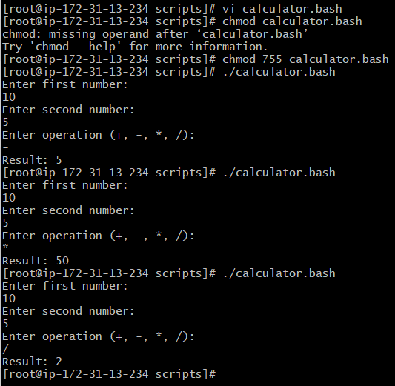
8: Create a bash script to check if a directory exists, if not then create a directory.
- vi check-create-dir.bash
#!/bin/bash
if [ -d /home/majeed/testdir ]
then
echo "Directory already exists"
else
mkdir /home/majeed/testdir
echo "Directory created successfully"
fi

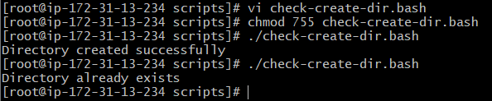
9: Create a bash script to delete the last 3 lines of a file.
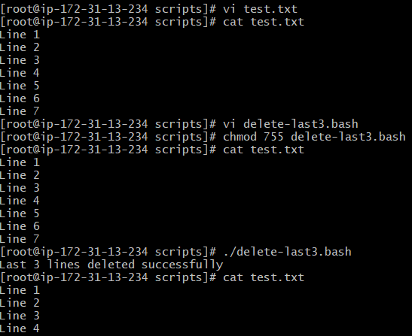
10: Bash script to monitor cpu and if it is more than 80% then send email notification.
- vi cpu-monitor.bash

#!/bin/bash

CPU=$(top -bn1 | awk '/Cpu\(s\)/ {print 100 - $8}')

echo "Current CPU usage: $CPU%"

if (( $(echo "$CPU > 80" | bc -l) ))
then
echo "CPU usage is above 80%"
echo "CPU usage is $CPU%" | mail -s "High CPU Alert" your-email@example.com
else
echo "CPU usage is normal"
fi
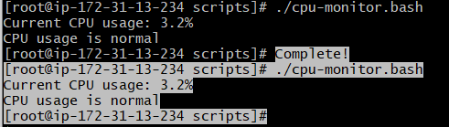

11: Bash script to monitor disk space and if it is more than 80% then send email notification.
vi disk-monitor.bash

#!/bin/bash

DISK=$(df / | awk 'NR==2 {print $5}' | sed 's/%//')

echo "Current disk usage: $DISK%"

if [ "$DISK" -gt 80 ]
then
echo "Disk usage is above 80%"
echo "Disk usage is $DISK%" | mail -s "High Disk Usage Alert" majkhan9160@gmail.com
else
echo "Disk usage is normal"
fi
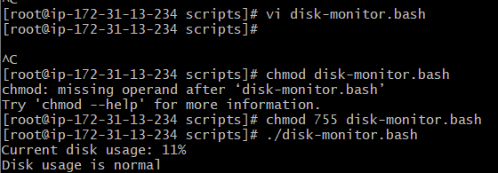

12: Bash script to monitor memory and if it is more than 80% then send email notification.
vi memory-monitor.bash
#!/bin/bash

MEMORY=$(free | awk '/Mem:/ {printf "%.0f", ($3/$2)*100}')

echo "Current memory usage: $MEMORY%"

if [ "$MEMORY" -gt 80 ]
then
echo "Memory usage is above 80%"
echo "Memory usage is $MEMORY%" | mail -s "High Memory Usage Alert" majkhan9160@gmail.com
else
echo "Memory usage is normal"
fi
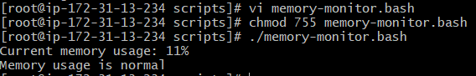

- Exercise: Crontab Entries:
A cron entry has 5 time fields:
Minute hour day-of-month month day-of-week
* * * * *
So:
* * * * *
│ │ │ │ │
│ │ │ │ └── day of week
│ │ │ └──── month
│ │ └────── day of month
│ └──────── hour
└────────── minute

- April 5th Midnight
- 5th of Every November, January, June if it is a Thursday
- At05 and 27th minutesof9, 10, 11hours every day
- 34 minutesof9th houron15th August
- Every midnight
- Every Weekend (Saturday night 11:59 PM)
- After every reboot

* * * * * /root/tes
0 0 5 4 * /root/tes
0 0 5 1,6,11 4 /root/tes
5,27 9,10,11 * * * /root/tes
34 9 15 8 * /root/tes
0 0 * * * /root/tes
59 23 * * 6 /root/tes
@reboot /root/tes

- All the scripts need to be executed onAmazon Linux EC2.
- Document all the tasks and also push the tasks to aGitHub repository(explore this for now).
- Share the documentand GitHub Repo URL once done for evaluation.

https://github.com/majeedkhan91/bash-linux-automation.git

